NAME : Shri Harshini Devi . A
REG.NO : 192524104
COURSE CODE : DSA0602
COURSE NAME : Data handling and Visualization

Class Activity: 15.07.2026

- Smart City Air Quality Monitoring:
install.packages("ggplot2")
install.packages("RColorBrewer")

library(ggplot2)
library(RColorBrewer)

set.seed(123)

air <- data.frame(
Sensor = 1:150,
X = runif(150, 1, 100),
Y = runif(150, 1, 100),
PM25 = runif(150, 20, 250),
NO2 = runif(150, 10, 100),
CO = runif(150, 0.5, 10),
Temperature = runif(150, 20, 40),
Humidity = runif(150, 40, 90)
)

# Sequential Color Scale
ggplot(air, aes(X, Y, color = PM25)) +
geom_point(size = 4) +
scale_color_gradient(low = "lightblue", high = "red") +
labs(
title = "Sequential Color Scale - PM2.5 Pollution",
x = "Location X",
y = "Location Y"
) +
theme_minimal()

# Diverging Color Scale
ggplot(air, aes(X, Y, color = PM25)) +
geom_point(size = 4) +
scale_color_gradient2(
low = "green",
mid = "yellow",
high = "red",
midpoint = 125
) +
labs(
title = "Diverging Color Scale",
x = "Location X",
y = "Location Y"
) +
theme_minimal()

# Qualitative Color Palette
air$Zone <- sample(c("North", "South", "East", "West"), 150, replace = TRUE)

ggplot(air, aes(X, Y, color = Zone)) +
geom_point(size = 4) +
scale_color_brewer(palette = "Set1") +
labs(
title = "Qualitative Color Palette",
x = "Location X",
y = "Location Y"
) +
theme_minimal()

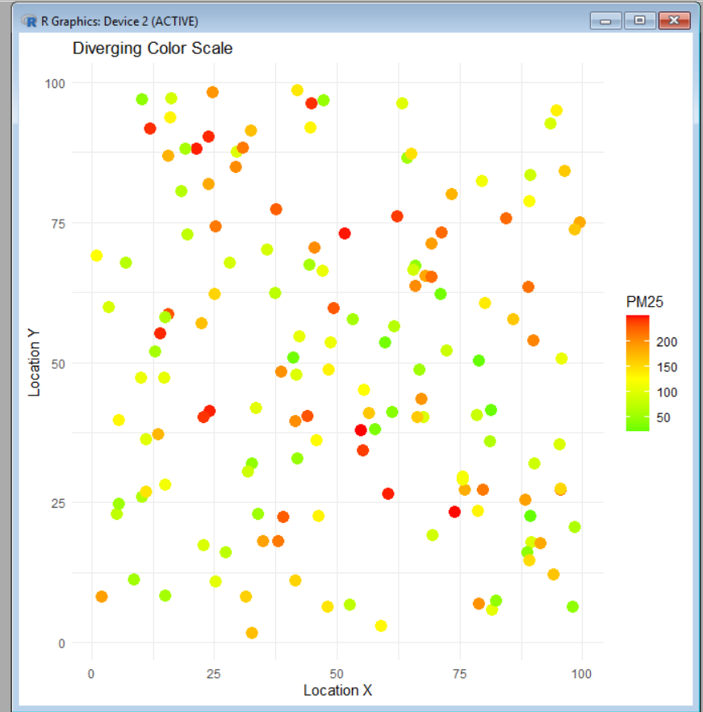

- Earthquake Risk Analysis:
library(ggplot2)

set.seed(123)

earthquake <- data.frame(
Magnitude = c(runif(450, 0.5, 3.5), runif(50, 4, 9.5)),
Depth = runif(500, 1, 700),
Latitude = runif(500, -90, 90),
Longitude = runif(500, -180, 180),
Aftershocks = sample(1:100, 500, replace = TRUE)
)

# Linear Scale Scatter Plot
ggplot(earthquake, aes(x = Magnitude, y = Depth, color = Aftershocks)) +
geom_point(size = 3) +
labs(
title = "Earthquake Distribution (Linear Scale)",
x = "Magnitude",
y = "Depth (km)"
) +
theme_minimal()

# Logarithmic Scale Scatter Plot
ggplot(earthquake, aes(x = Magnitude, y = Depth, color = Aftershocks)) +
geom_point(size = 3) +
scale_x_log10() +
labs(
title = "Earthquake Distribution (Logarithmic Scale)",
x = "Magnitude (Log Scale)",
y = "Depth (km)"
) +
theme_minimal()

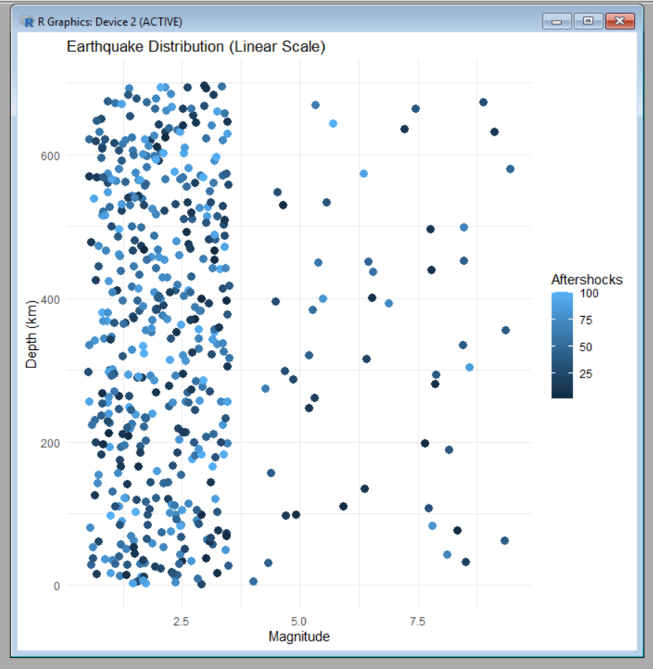

- Wind Direction Analysis for Airport Operations:
library(ggplot2)

set.seed(123)

wind <- data.frame(
WindSpeed = runif(365, 5, 50),
WindDirection = runif(365, 0, 360),
Season = sample(c("Winter", "Summer", "Monsoon", "Post-Monsoon"),
365, replace = TRUE)
)

# Cartesian Plot
ggplot(wind, aes(x = WindDirection, y = WindSpeed, color = Season)) +
geom_point(size = 3) +
labs(
title = "Wind Speed vs Wind Direction (Cartesian Plot)",
x = "Wind Direction (Degrees)",
y = "Wind Speed (km/h)"
) +
theme_minimal()

# Polar Coordinate (Wind Rose)
ggplot(wind, aes(x = factor(round(WindDirection/30)*30), fill = Season)) +
geom_bar() +
coord_polar(start = 0) +
labs(
title = "Wind Rose",
x = "Wind Direction",
y = "Frequency"
) +
theme_minimal()

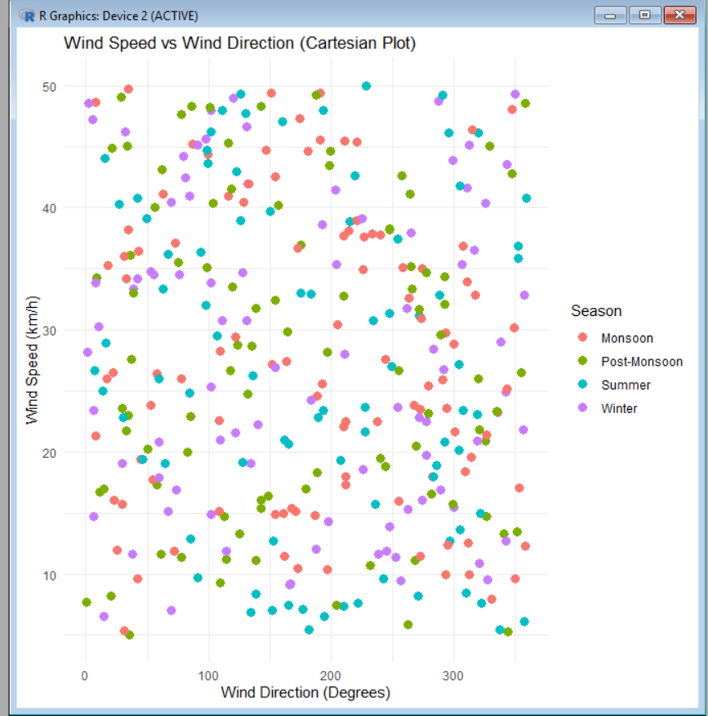

- Hospital Patient Monitoring Dashboard:
library(ggplot2)

vital <- c("Heart Rate", "SpO2", "Blood Pressure",
"Respiration", "Temperature")

value <- c(105, 88, 145, 22, 39.2)

status <- c("Warning", "Critical", "Alert",
"Warning", "Critical")

df <- data.frame(vital, value, status)

ggplot(df, aes(x = vital, y = value, fill = status)) +
geom_col(width = 0.7) +
geom_text(aes(label = value), vjust = -0.5, size = 5) +
scale_fill_manual(values = c(
"Normal" = "green",
"Warning" = "yellow",
"Alert" = "orange",
"Critical" = "red"
)) +
labs(
title = "ICU Patient Monitoring Dashboard",
x = "Vital Signs",
y = "Current Reading"
) +
theme_minimal() +
theme(
plot.title = element_text(size = 18, face = "bold", hjust = 0.5),
legend.title = element_blank()
)

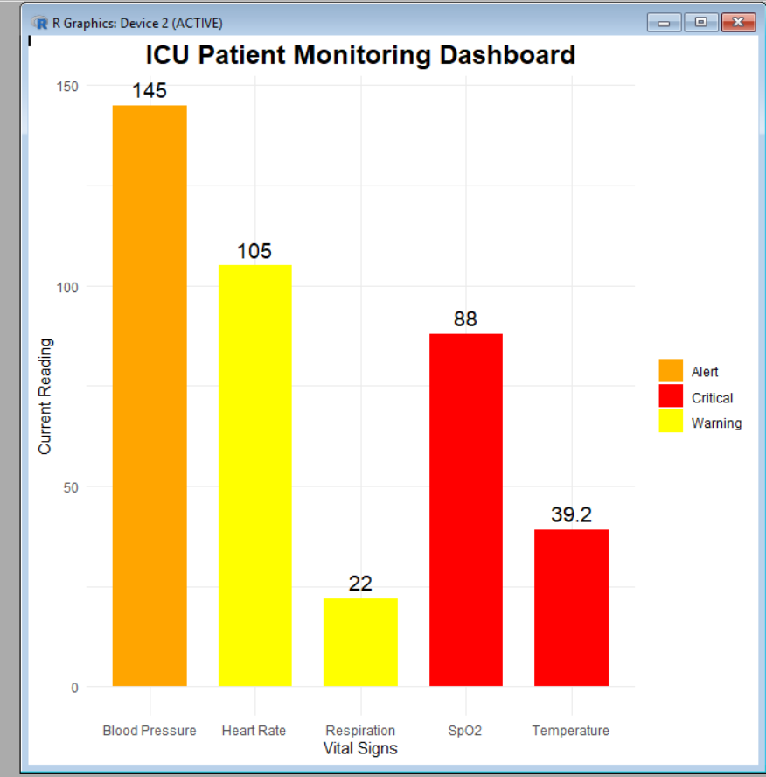

5)Global Climate Change Study:
#-----------------------------
# Global Climate Change Study
# Heatmaps using Diverging Color Palettes
#-----------------------------

# Install packages (Run once)
install.packages("ggplot2")
install.packages("RColorBrewer")
install.packages("viridis")

# Load libraries
library(ggplot2)
library(RColorBrewer)
library(viridis)

# Create Sample Dataset
set.seed(123)

countries <- paste("Country", 1:180)
years <- 1980:2025

climate <- expand.grid(
Country = countries,
Year = years
)

# Generate temperature anomalies (-3°C to +3°C)
climate$Anomaly <- rnorm(nrow(climate), mean = 0.5, sd = 1)

# Limit values
climate$Anomaly[climate$Anomaly > 3] <- 3
climate$Anomaly[climate$Anomaly < -3] <- -3

#--------------------------------------------------
# Heatmap 1 : Blue - White - Red
#--------------------------------------------------
ggplot(climate, aes(x = Year, y = Country, fill = Anomaly)) +
geom_tile() +
scale_fill_gradient2(
low = "blue",
mid = "white",
high = "red",
midpoint = 0,
limits = c(-3, 3),
name = "Anomaly"
) +
labs(
title = "Heatmap - Blue White Red Palette",
x = "Year",
y = "Country"
) +
theme_minimal() +
theme(axis.text.y = element_blank())

#--------------------------------------------------
# Heatmap 2 : RdBu Palette
#--------------------------------------------------
ggplot(climate, aes(x = Year, y = Country, fill = Anomaly)) +
geom_tile() +
scale_fill_distiller(
palette = "RdBu",
direction = -1,
limits = c(-3, 3),
name = "Anomaly"
) +
labs(
title = "Heatmap - RdBu Palette",
x = "Year",
y = "Country"
) +
theme_minimal() +
theme(axis.text.y = element_blank())

#--------------------------------------------------
# Heatmap 3 : PRGn Palette
#--------------------------------------------------
ggplot(climate, aes(x = Year, y = Country, fill = Anomaly)) +
geom_tile() +
scale_fill_distiller(
palette = "PRGn",
direction = -1,
limits = c(-3, 3),
name = "Anomaly"
) +
labs(
title = "Heatmap - PRGn Palette",
x = "Year",
y = "Country"
) +
theme_minimal() +
theme(axis.text.y = element_blank())

#--------------------------------------------------
# Comparison
#--------------------------------------------------
cat("\nComparison of Diverging Color Palettes\n")
cat("--------------------------------------\n")
cat("1. Blue-White-Red : Best overall; intuitive for cold (blue) and warm (red) anomalies.\n")
cat("2. RdBu : Widely used in scientific research with balanced contrast.\n")
cat("3. PRGn : Good for users with many forms of color vision deficiency, though less intuitive for temperature.\n\n")

cat("Conclusion:\n")
cat("Blue-White-Red communicates positive and negative temperature anomalies most effectively because it uses familiar climate colors, has a neutral midpoint (white), and provides clear visual separation. RdBu is suitable for scientific publications, while PRGn improves accessibility for many users with color vision deficiencies.\n")
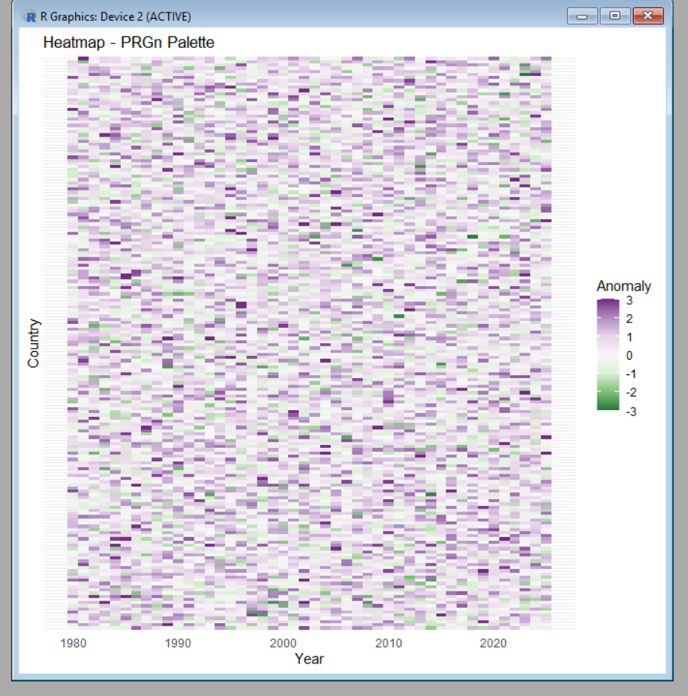

6)E-Commerce Sales Analytics:
#---------------------------------------------
# E-Commerce Sales Analytics
# Color for Categories + Sales Volume
#---------------------------------------------

# Install packages (Run once)
install.packages("ggplot2")
install.packages("viridis")
install.packages("RColorBrewer")

# Load libraries
library(ggplot2)
library(viridis)
library(RColorBrewer)

# Create Sample Dataset
set.seed(123)

categories <- paste("Category", 1:50)
regions <- paste("Region", 1:30)

sales <- expand.grid(
Category = categories,
Region = regions
)

# Generate random sales values
sales$Sales <- sample(1000:100000, nrow(sales), replace = TRUE)

#-------------------------------------------------
# Visualization 1:
# Categories distinguished by color
# Sales represented by point size
#-------------------------------------------------
ggplot(sales,
aes(x = Region,
y = Category,
color = Category,
size = Sales)) +
geom_point(alpha = 0.8) +
labs(
title = "E-Commerce Sales Analytics",
subtitle = "Category by Color, Sales by Point Size",
x = "Region",
y = "Product Category"
) +
theme_minimal() +
theme(axis.text.x = element_text(angle = 90),
legend.position = "right")

#-------------------------------------------------
# Visualization 2:
# Sales represented by color intensity
#-------------------------------------------------
ggplot(sales,
aes(x = Region,
y = Category,
fill = Sales)) +
geom_tile(color = "white") +
scale_fill_viridis_c(option = "C") +
labs(
title = "Sales Volume Heatmap",
x = "Region",
y = "Product Category",
fill = "Sales"
) +
theme_minimal() +
theme(axis.text.x = element_text(angle = 90))

#-------------------------------------------------
# Discussion
#-------------------------------------------------
cat("\nChallenges of Combining Qualitative and Quantitative Color Encoding\n")
cat("---------------------------------------------------------------\n")
cat("1. With 50 product categories, assigning unique colors becomes difficult.\n")
cat("2. Using color for both categories and sales values may confuse users.\n")
cat("3. Too many colors reduce readability and increase visual clutter.\n")
cat("4. Colorblind users may struggle to distinguish similar colors.\n")
cat("5. Sequential color scales are best for numerical values, while qualitative palettes are best for categories.\n")
cat("6. A better approach is to use color for categories and another visual cue (size or shape) for sales volume.\n")

cat("\nConclusion:\n")
cat("Combining qualitative and quantitative color encoding is challenging because color serves two different purposes. Using distinct colors for categories and point size or a separate sequential color scale for sales values improves clarity, interpretability, and accessibility.\n")
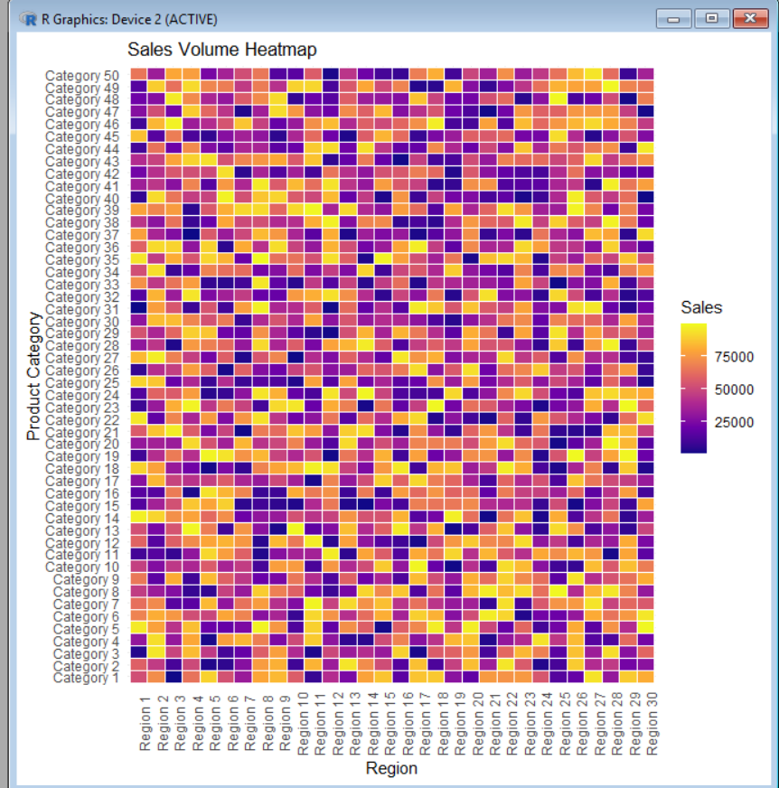

7) Satellite Image Vegetation Analysis:
#---------------------------------------------
# Satellite Image Vegetation Analysis (NDVI)
# Sequential and Diverging Color Palettes
#---------------------------------------------

# Install packages (Run once)
install.packages("ggplot2")
install.packages("viridis")
install.packages("RColorBrewer")

# Load libraries
library(ggplot2)
library(viridis)
library(RColorBrewer)

# Create Sample NDVI Dataset
set.seed(123)

x <- 1:100
y <- 1:100

ndvi <- expand.grid(X = x, Y = y)

# Generate NDVI values (-1 to +1)
ndvi$NDVI <- runif(nrow(ndvi), min = -1, max = 1)

#-------------------------------------------------
# Visualization 1:
# Sequential Palette (Viridis)
#-------------------------------------------------
ggplot(ndvi, aes(x = X, y = Y, fill = NDVI)) +
geom_tile() +
scale_fill_viridis_c(option = "D") +
labs(
title = "NDVI Visualization - Viridis Sequential Palette",
x = "Longitude",
y = "Latitude",
fill = "NDVI"
) +
theme_minimal()

#-------------------------------------------------
# Visualization 2:
# Sequential Palette (Greens)
#-------------------------------------------------
ggplot(ndvi, aes(x = X, y = Y, fill = NDVI)) +
geom_tile() +
scale_fill_distiller(palette = "Greens") +
labs(
title = "NDVI Visualization - Greens Palette",
x = "Longitude",
y = "Latitude",
fill = "NDVI"
) +
theme_minimal()

#-------------------------------------------------
# Visualization 3:
# Diverging Palette (Brown-White-Green)
#-------------------------------------------------
ggplot(ndvi, aes(x = X, y = Y, fill = NDVI)) +
geom_tile() +
scale_fill_gradient2(
low = "brown",
mid = "white",
high = "darkgreen",
midpoint = 0,
limits = c(-1, 1),
name = "NDVI"
) +
labs(
title = "NDVI Visualization - Diverging Palette",
x = "Longitude",
y = "Latitude"
) +
theme_minimal()

#-------------------------------------------------
# Evaluation
#-------------------------------------------------
cat("\nEvaluation of Color Palettes\n")
cat("--------------------------------------------\n")
cat("1. Viridis Sequential Palette:\n")
cat(" - Excellent readability.\n")
cat(" - Colorblind-friendly.\n")
cat(" - Best for displaying continuous NDVI values.\n\n")

cat("2. Greens Sequential Palette:\n")
cat(" - Highlights vegetation effectively.\n")
cat(" - Negative NDVI values are difficult to distinguish.\n\n")

cat("3. Brown-White-Green Diverging Palette:\n")
cat(" - Brown = Barren Land\n")
cat(" - White = Neutral (NDVI ≈ 0)\n")
cat(" - Green = Healthy Vegetation\n")
cat(" - Clearly separates water/barren areas from vegetation.\n\n")

cat("Conclusion:\n")
cat("The Brown-White-Green diverging palette minimizes interpretation errors because it clearly distinguishes negative NDVI (water/barren land), neutral areas, and healthy vegetation. Viridis is the most accessible palette for users with color vision deficiencies, while Greens is suitable only when focusing mainly on vegetation.\n")
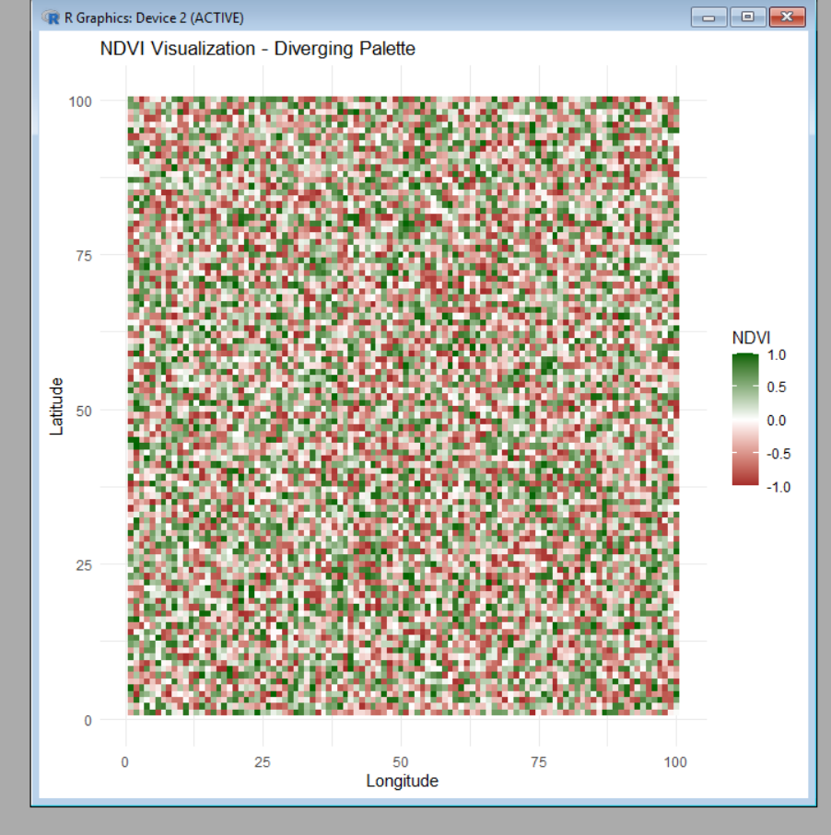

8) Cryptocurrency Market Volatility:

#----------------------------------------------------
# Cryptocurrency Market Volatility
# Cartesian Plot vs Logarithmic Axis
#----------------------------------------------------

# Install packages (Run once)
install.packages("ggplot2")

# Load library
library(ggplot2)

# Create Sample Dataset
set.seed(123)

dates <- seq(as.Date("2021-01-01"), as.Date("2024-12-31"), by = "month")
crypto <- c("Bitcoin", "Ethereum", "Solana", "Cardano")

data <- expand.grid(
Date = dates,
Cryptocurrency = crypto
)

# Generate sample prices
data$Price <- c(
runif(length(dates), 20000, 70000), # Bitcoin
runif(length(dates), 1000, 5000), # Ethereum
runif(length(dates), 20, 250), # Solana
runif(length(dates), 0.2, 3) # Cardano
)

#----------------------------------------------------
# Visualization 1: Cartesian Line Plot
#----------------------------------------------------
ggplot(data,
aes(x = Date,
y = Price,
color = Cryptocurrency,
group = Cryptocurrency)) +
geom_line(size = 1) +
labs(
title = "Cryptocurrency Prices (Cartesian Scale)",
x = "Date",
y = "Price (USD)"
) +
theme_minimal()

#----------------------------------------------------
# Visualization 2: Logarithmic Y-Axis
#----------------------------------------------------
ggplot(data,
aes(x = Date,
y = Price,
color = Cryptocurrency,
group = Cryptocurrency)) +
geom_line(size = 1) +
scale_y_log10() +
labs(
title = "Cryptocurrency Prices (Logarithmic Scale)",
x = "Date",
y = "Log10 Price (USD)"
) +
theme_minimal()

#----------------------------------------------------
# Comparison
#----------------------------------------------------
cat("\nComparison of Cartesian and Logarithmic Axes\n")
cat("-------------------------------------------------\n")
cat("1. Cartesian Plot:\n")
cat(" - Displays actual price values.\n")
cat(" - High-priced assets dominate the graph.\n")
cat(" - Small-price cryptocurrencies appear nearly flat.\n\n")

cat("2. Logarithmic Axis:\n")
cat(" - Compresses large values.\n")
cat(" - Makes growth rates easier to compare.\n")
cat(" - Clearly shows trends for all cryptocurrencies.\n\n")

cat("Benefits of Nonlinear (Logarithmic) Axes:\n")
cat("- Enables comparison of assets with vastly different prices.\n")
cat("- Highlights percentage growth instead of absolute differences.\n")
cat("- Reduces dominance of high-value cryptocurrencies.\n\n")

cat("Limitations:\n")
cat("- Less intuitive for beginners.\n")
cat("- Exact price differences are harder to interpret.\n")
cat("- Cannot represent zero or negative values.\n\n")

cat("Conclusion:\n")
cat("Use distinct colors to differentiate Bitcoin, Ethereum, Solana, and Cardano. A logarithmic axis provides better visual clarity for comparing cryptocurrencies with prices spanning several orders of magnitude, while a Cartesian axis is preferable when actual price values are the focus.\n")

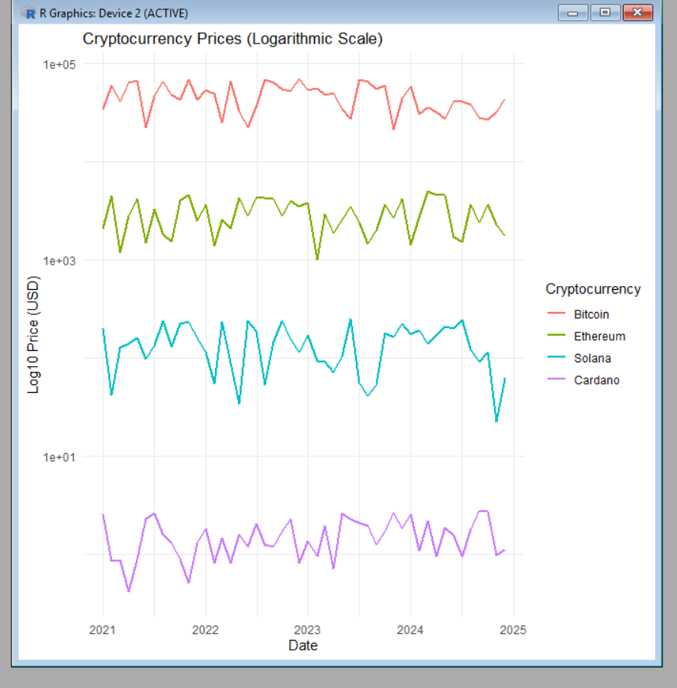

9) Marathon Runner Performance Analysis:
# Sample Data
distance <- seq(0, 42, by = 2)
speed <- c(10,11,12,12.5,13,12.8,12.5,12.3,12,11.8,11.5,
11.3,11,10.8,10.5,10.2,10,9.8,9.6,9.5,9.3,9)

heart_rate <- seq(120,180,length.out=length(distance))

library(ggplot2)

ggplot(data.frame(distance,speed,heart_rate),
aes(x=distance, y=speed, color=heart_rate)) +
geom_line(size=1.2) +
geom_point(size=3) +
scale_color_gradient(low="green", high="red") +
labs(title="Runner Speed vs Distance",
x="Distance (km)",
y="Speed (km/h)",
color="Heart Rate") +
theme_minimal()
library(ggplot2)

direction <- seq(0,360,length.out=length(distance))

data <- data.frame(direction,distance,speed)

ggplot(data,
aes(x=factor(direction), y=distance, fill=speed)) +
geom_bar(stat="identity") +
coord_polar() +
scale_fill_gradient(low="green", high="red") +
labs(title="Runner Direction and Speed",
fill="Speed") +
theme_minimal()

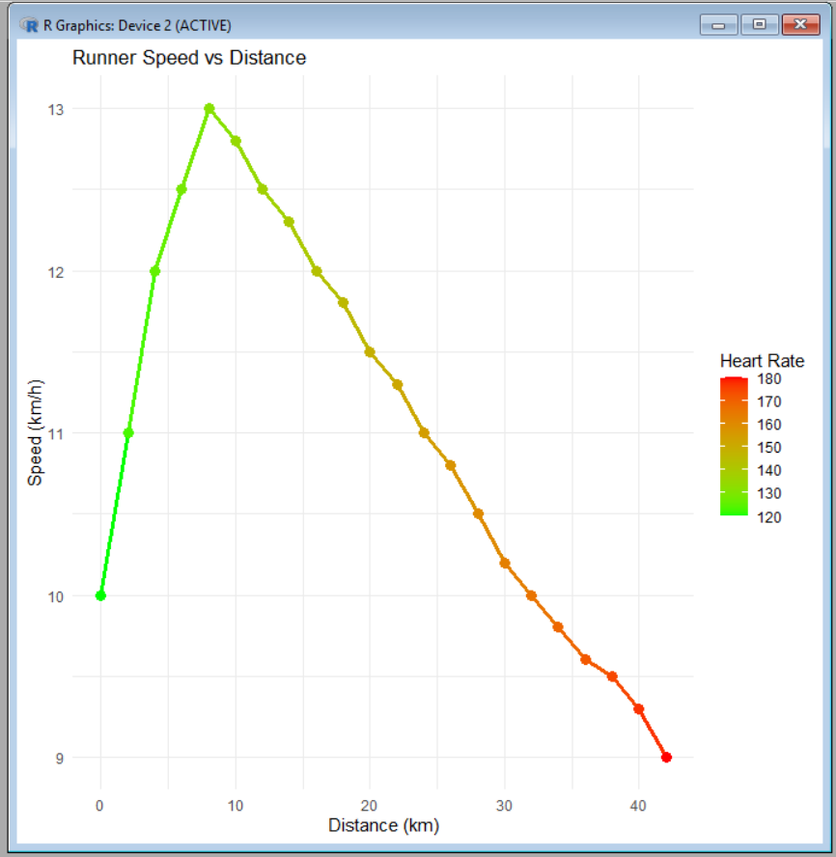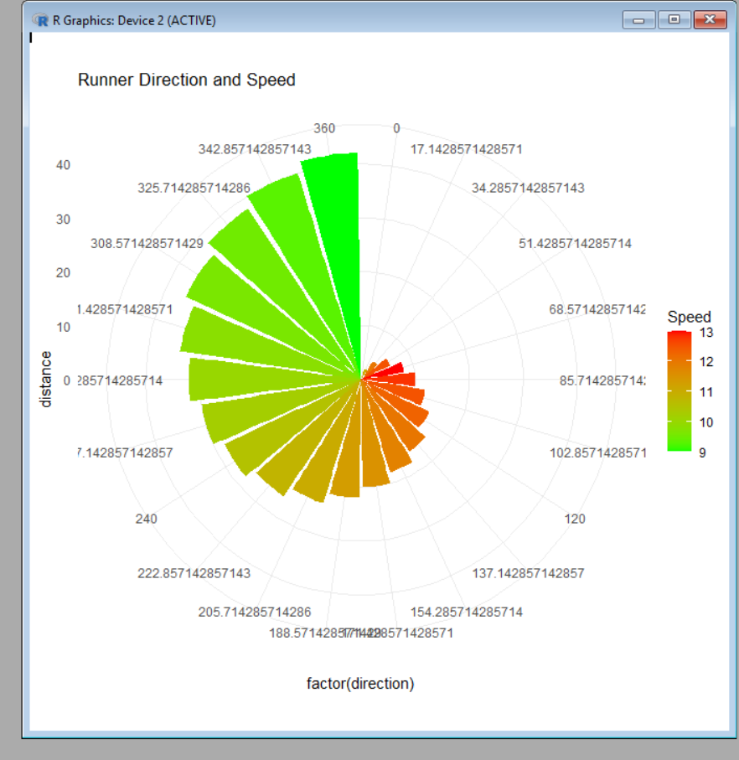

10) COVID-19 Vaccination Campaign Dashboard:

# Install ggplot2 (Run only once)
install.packages("ggplot2")

# Load library
library(ggplot2)

# Sample Data
vaccination <- data.frame(
District = c("North", "South", "East", "West", "Central"),
Coverage = c(92, 78, 65, 85, 55)
)

# Version 1 - Policymaker Dashboard
ggplot(vaccination, aes(x = District, y = Coverage, fill = Coverage)) +
geom_bar(stat = "identity") +
scale_fill_gradient(low = "blue", high = "red") +
labs(title = "COVID-19 Vaccination Dashboard (Policymaker)",
x = "District",
y = "Vaccination Rate (%)") +
theme_minimal()

# Version 2 - Public Dashboard
ggplot(vaccination, aes(x = District, y = Coverage, fill = Coverage)) +
geom_bar(stat = "identity") +
scale_fill_gradient(low = "lightgreen", high = "darkgreen") +
labs(title = "COVID-19 Vaccination Dashboard (Public)",
x = "District",
y = "Vaccination Rate (%)") +
theme_light()

